***Movies Reviews Analysis- A Tale of 6 Decades***

# 1. Loading Datasets into Pandas Dataframes

In this phase we are going to basically load all-important Dataframes related to movies analysis. We are going to add some more features like date and years etc to be able to view our dataset in a better way.

**Code:** 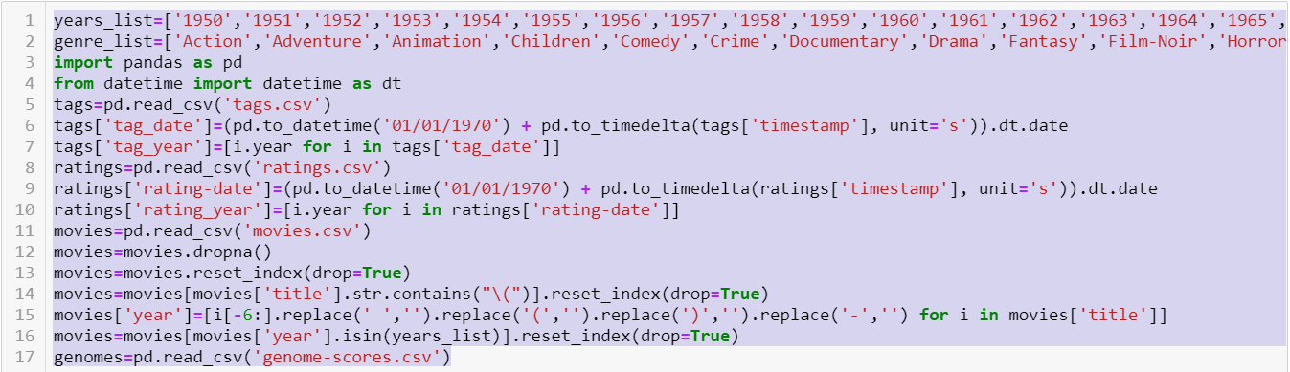

# 2. Impact of Technology on Movie Industry

First of all lets see what technology has been able to bring in to Viewers and what has accordingly changed.

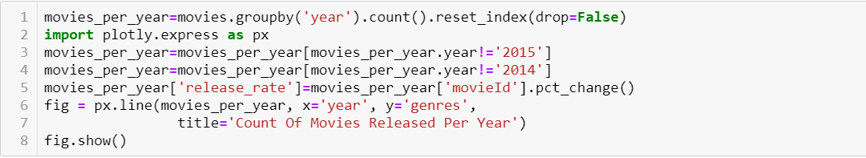

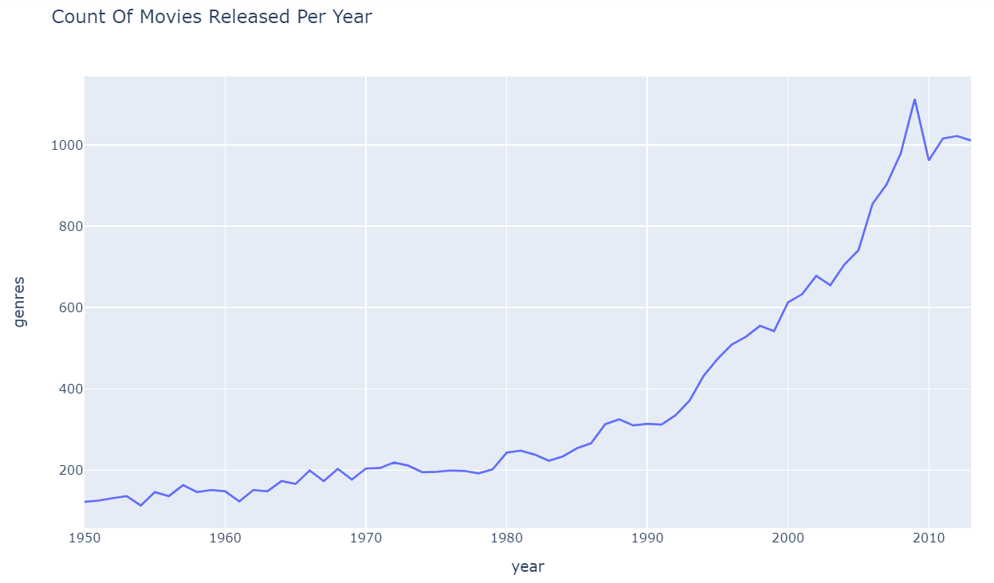

As you can see this is the very first impact of digitalization has been able to bring. We are seeing anormus increase in the release.Almost 10times increase over the period of 50 years.

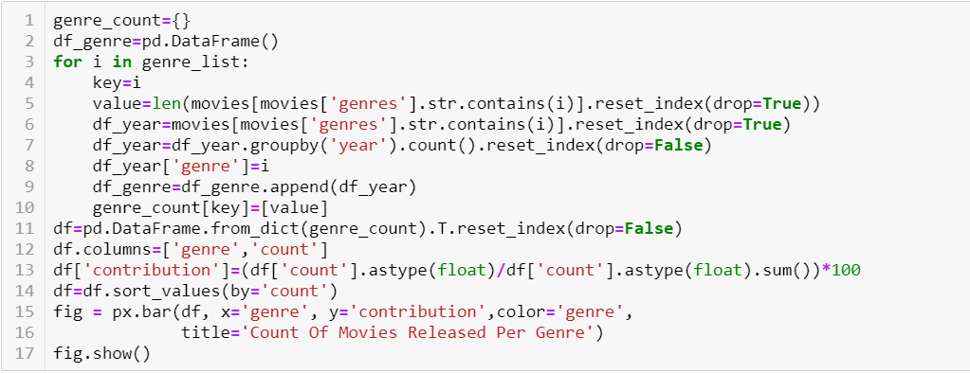

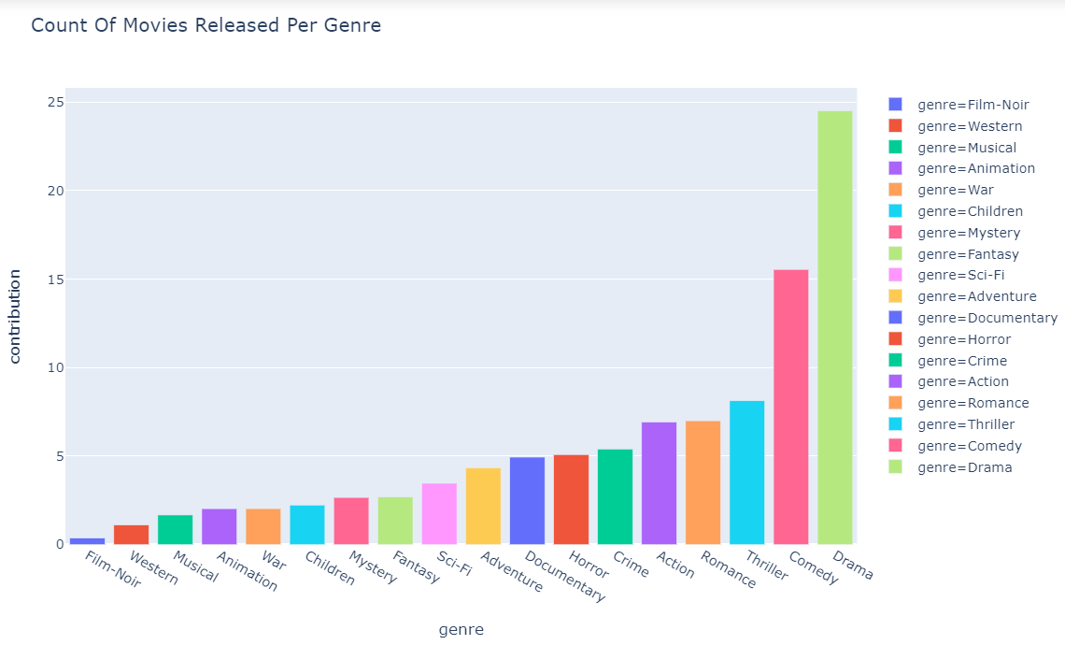

Drama and Comedy is somewhat has been most popular in Demand as we can see but we can certainly see the increase and now we are going to analyze the impact on each genre.

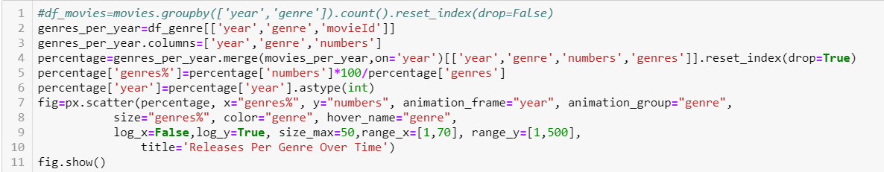

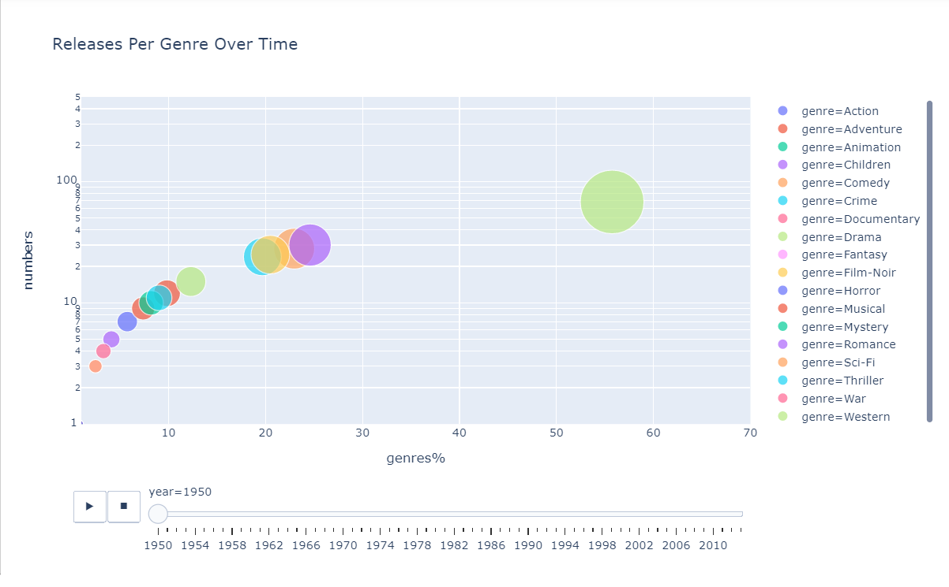

This Animation clearly shows that over the course of time, Drama has been the biggest contributor. Although Comedy is second best. All Genre show improvement in numbers because movie making has become easier over time.



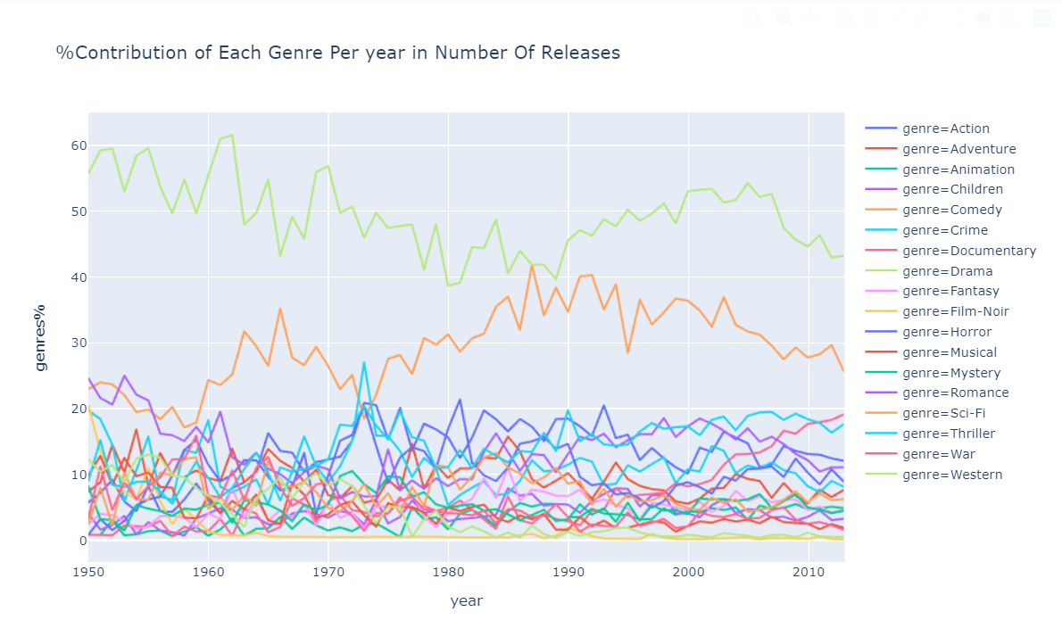

Although we can see the Contribution rates going up and down for some Genres buts lets plot all separately to see the clear picture.

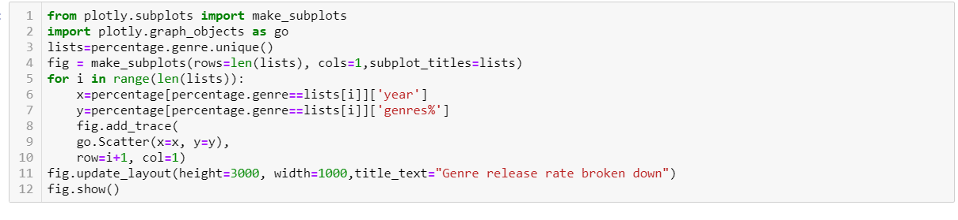

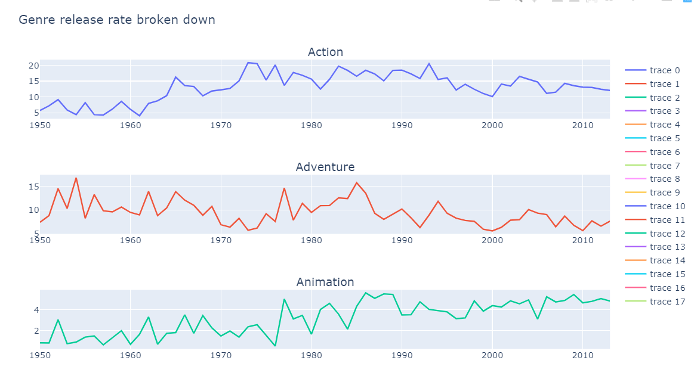

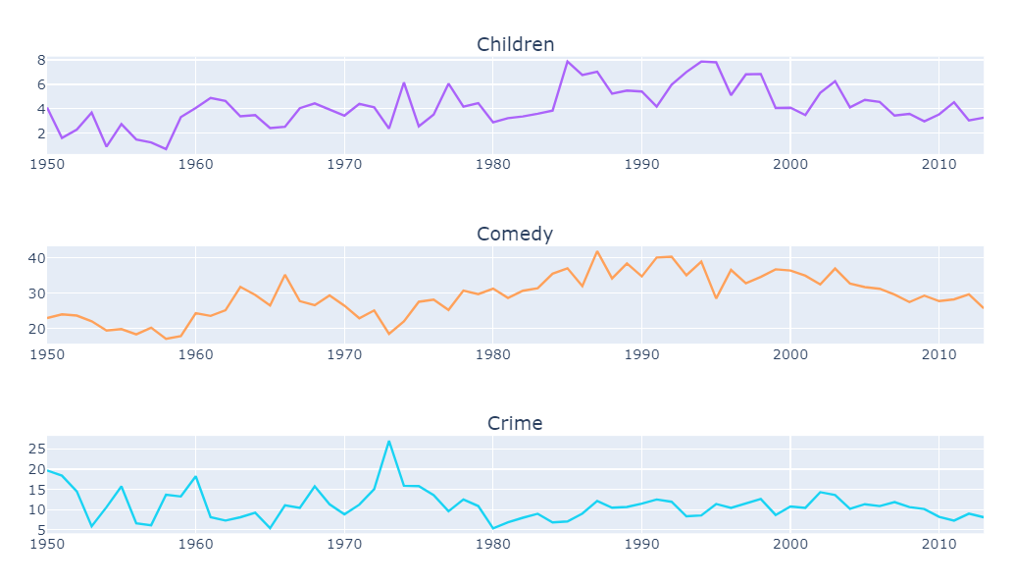

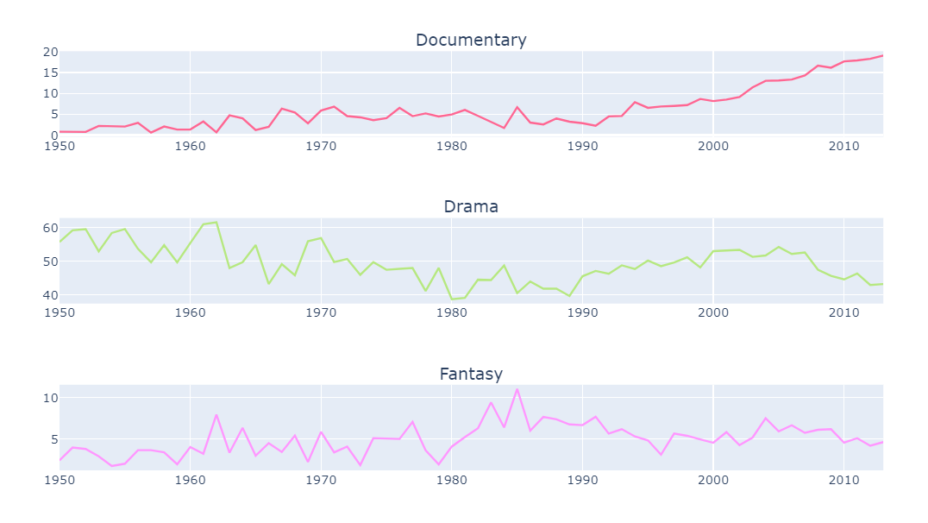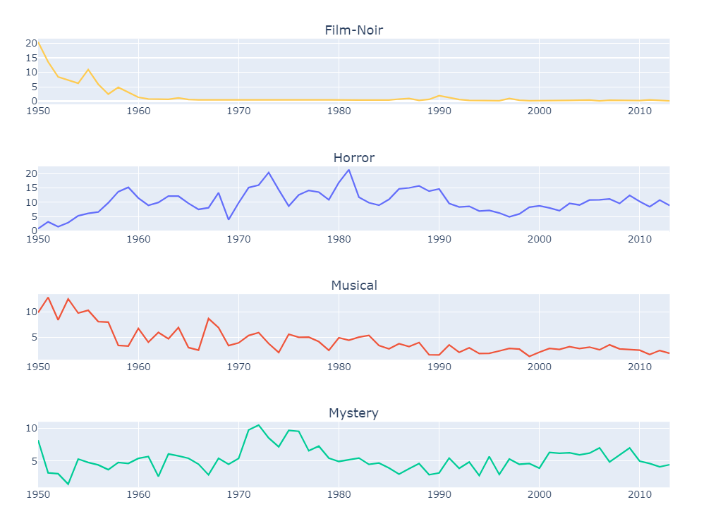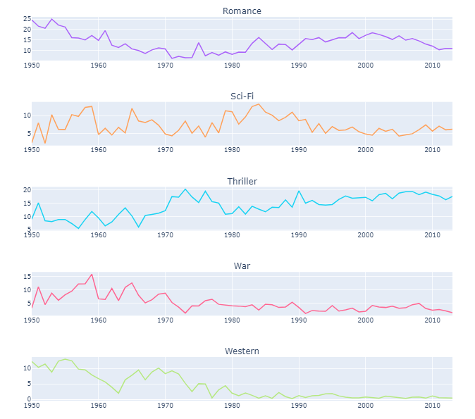

Technology has actually almost diminished Film-Noirs and Musical Genres. While Action, Animation, Scify are thriving

# 3. You not always understand what you watch

## 3.1 Lets See review Tags:

Here we will Analyze the number of Tags associated with each Genre and then will try to reach a conclusion about tag relevance and critics.

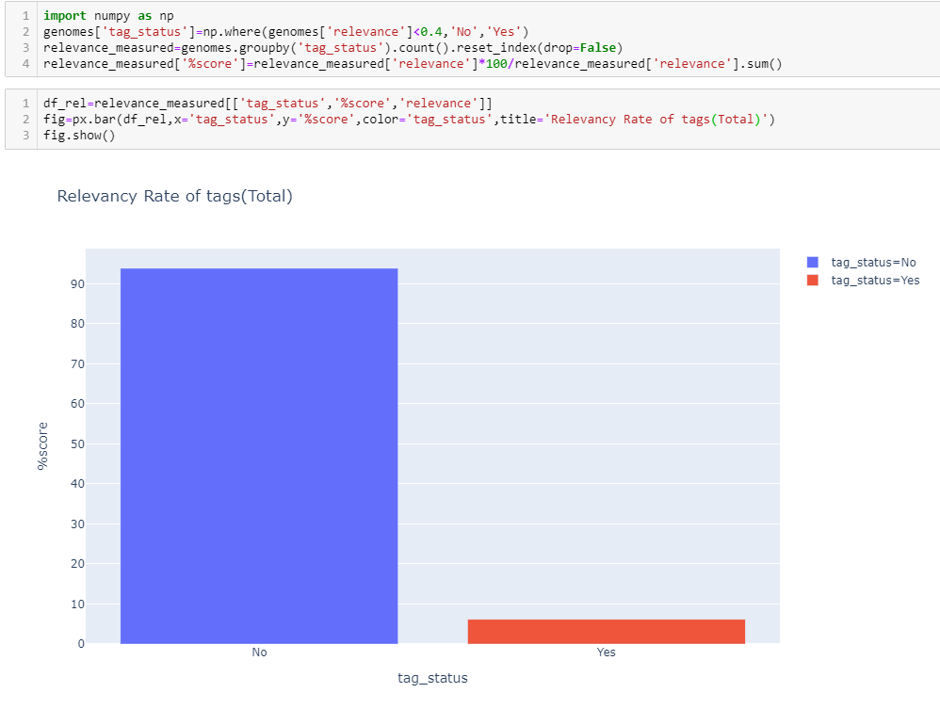Next Time before a Writing the Tag, I think its better to see the statistics above that where would you fall. 94% of the tags are irrelevant to the genre or the movie itself. But We will drill it to down to see which audience is the best or the worst judge of their Genre.

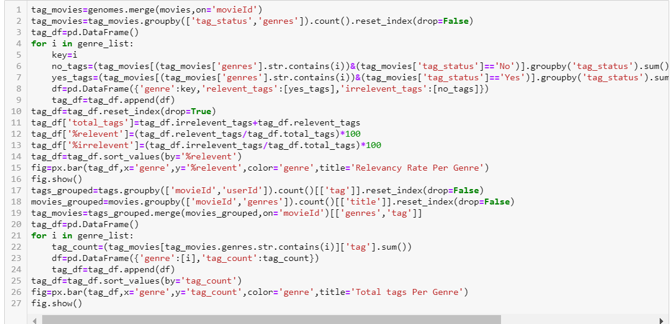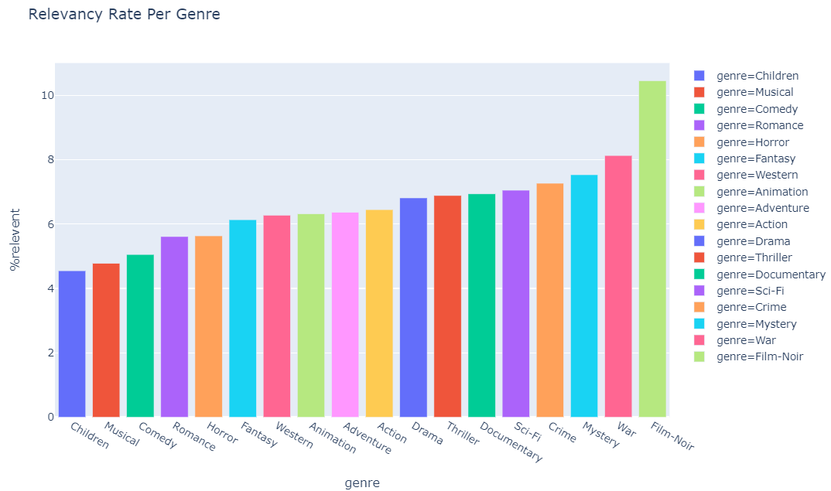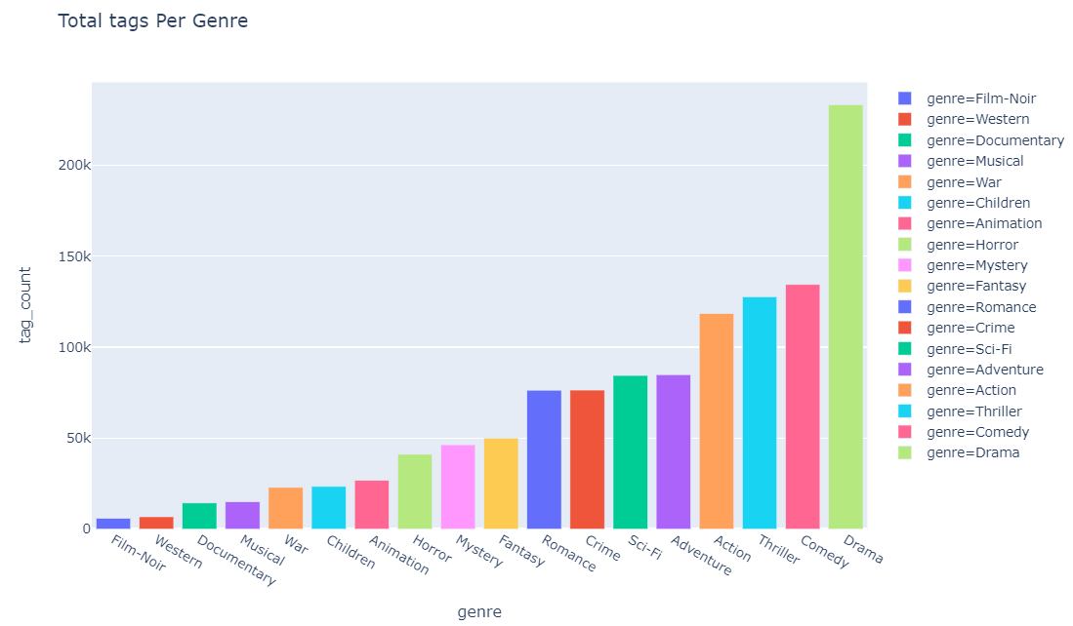

Oops! Stats are self-Explaining. Relevant Tags of Most Watched or Rated are Nowhere near the relevance. It is Film-Noir, War, Mystery and crimes whose viewers know up to some extent what they actually watched. But Still Stats are shockingly bad

## 3.2 Ratings: Oo we will see now

## Most of the reviews belong to the most released genres. I think our movie makers know these stats for sure. Or could it be the other way round. May be ! But for now we are assuming that most released genres have most number of ratings per user.

## 

## 

## This Animation shows that most number of reviews have been collected during the time technology and Social media really hit the ground and it as not been able to stop since then

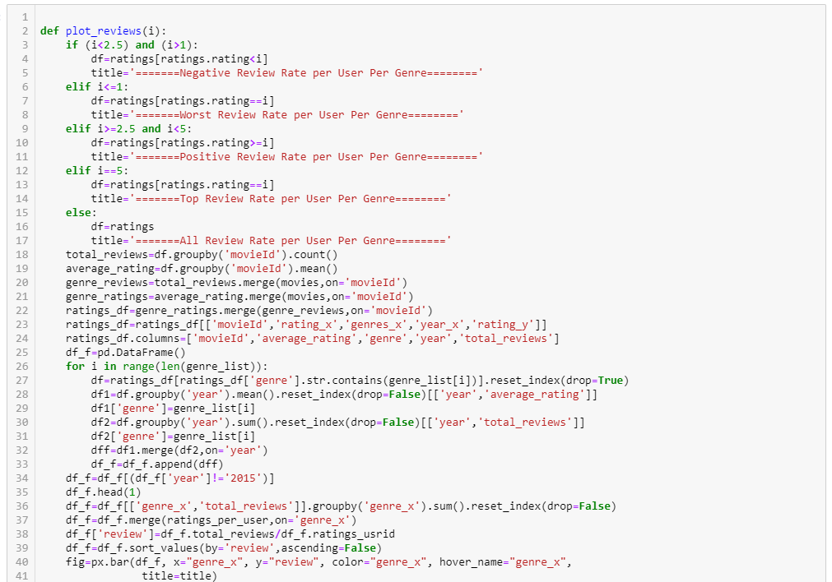

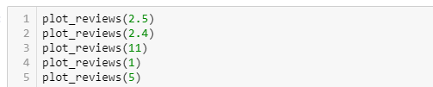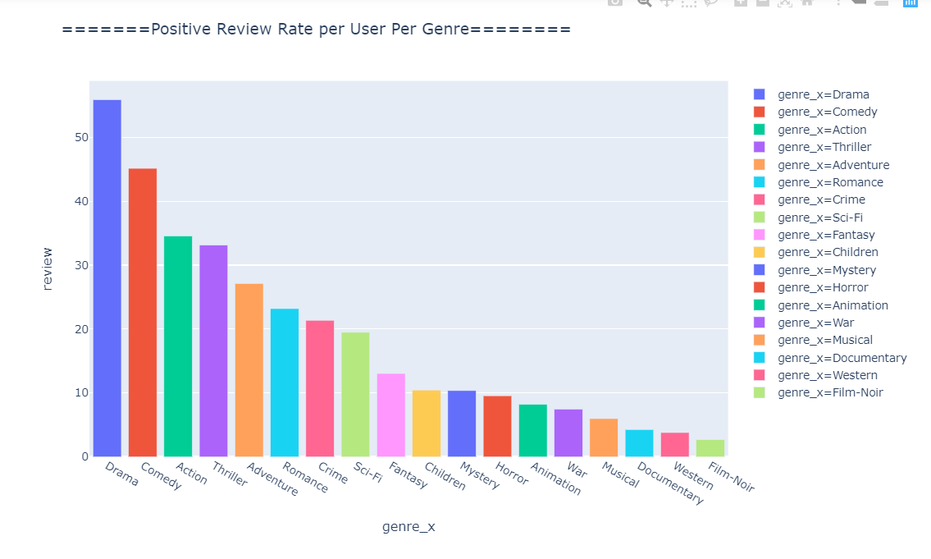

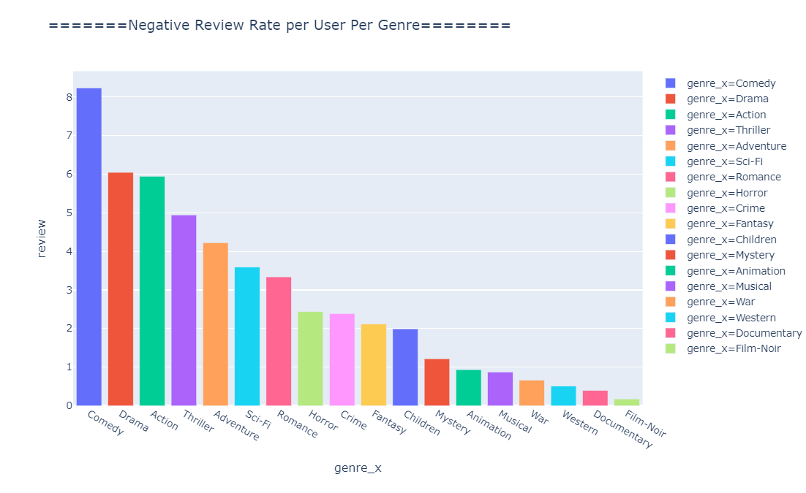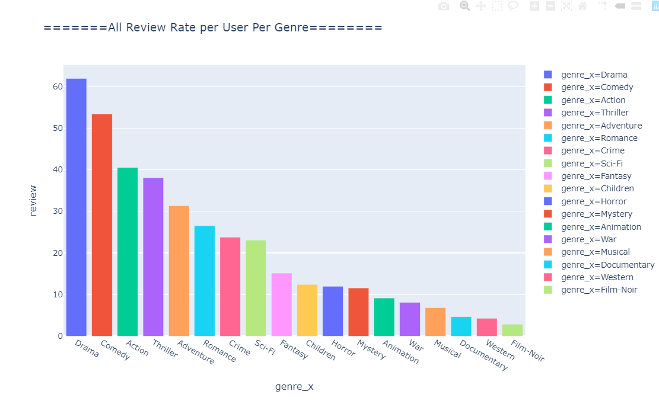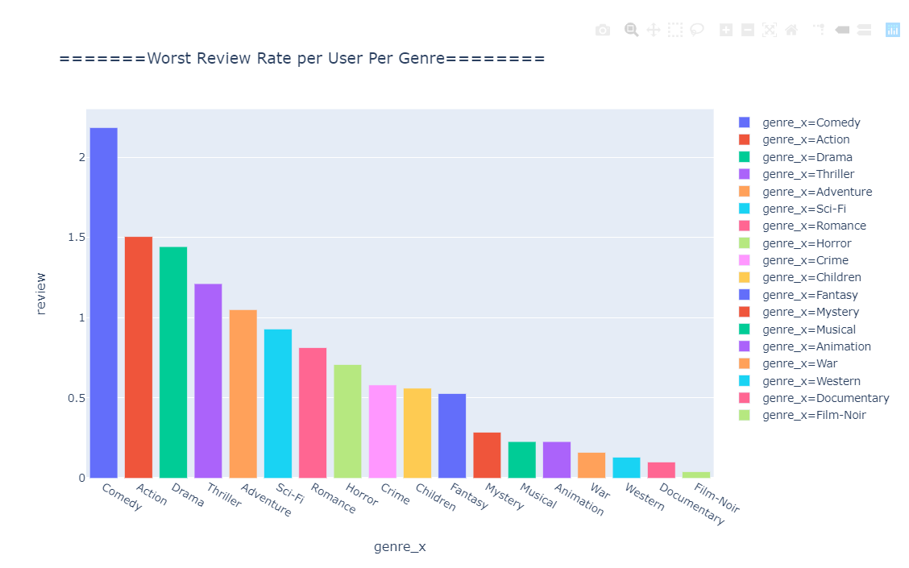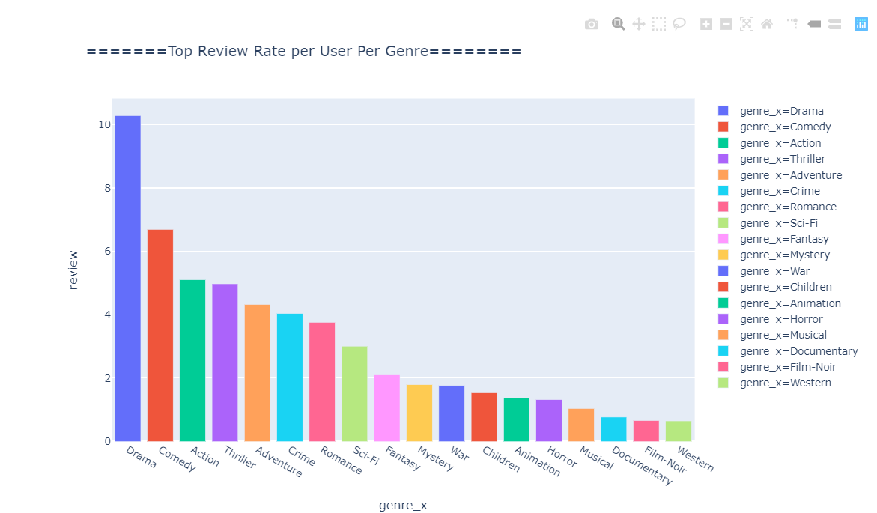Although Most number of reviews per users are being written by Audiance of Drama but maximum number of -ive reviews are being put there but comedy watchers. Top negative reviews are being written by Comedy and action watchers may be because of the bar set by the Top rated movies in respective genres

# 4. Top 50 Most Watched and Top Rated Movies: Where do they belong

So we can conclude based on the Statistics above that people now a days watch Action and adventure most of the time. Though they like it, we are not so sure because Top rated Genre includes Drama, crime and thriller. So while based on the ratings i would suggest to act the same way.